Sean Murphy

Z23642875

1/28/2023 5:45PM

Git Hub Username: seanm519 or Sean Murphy

Git Hub Repository: https://github.com/cop4808-spring-2023-fullstack-web/cop4808-git-and-github-fundamentals-seanm519.git

Objective 1:

For this objective I downloaded Git Bash and cloned the repository using the terminal. I also updated the readme with my name and committed and pushed the result.

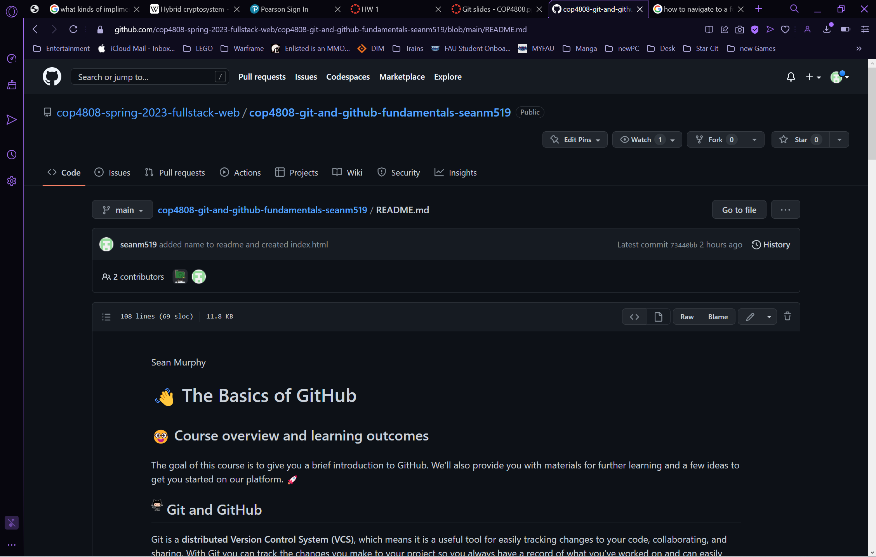

Objective 2:

I installed Visual Studio Code with the Live Server and a preview tool created by Microsoft.

Next I create the index.html file with the “Hello HTML World” text in it and committed and pushed it.

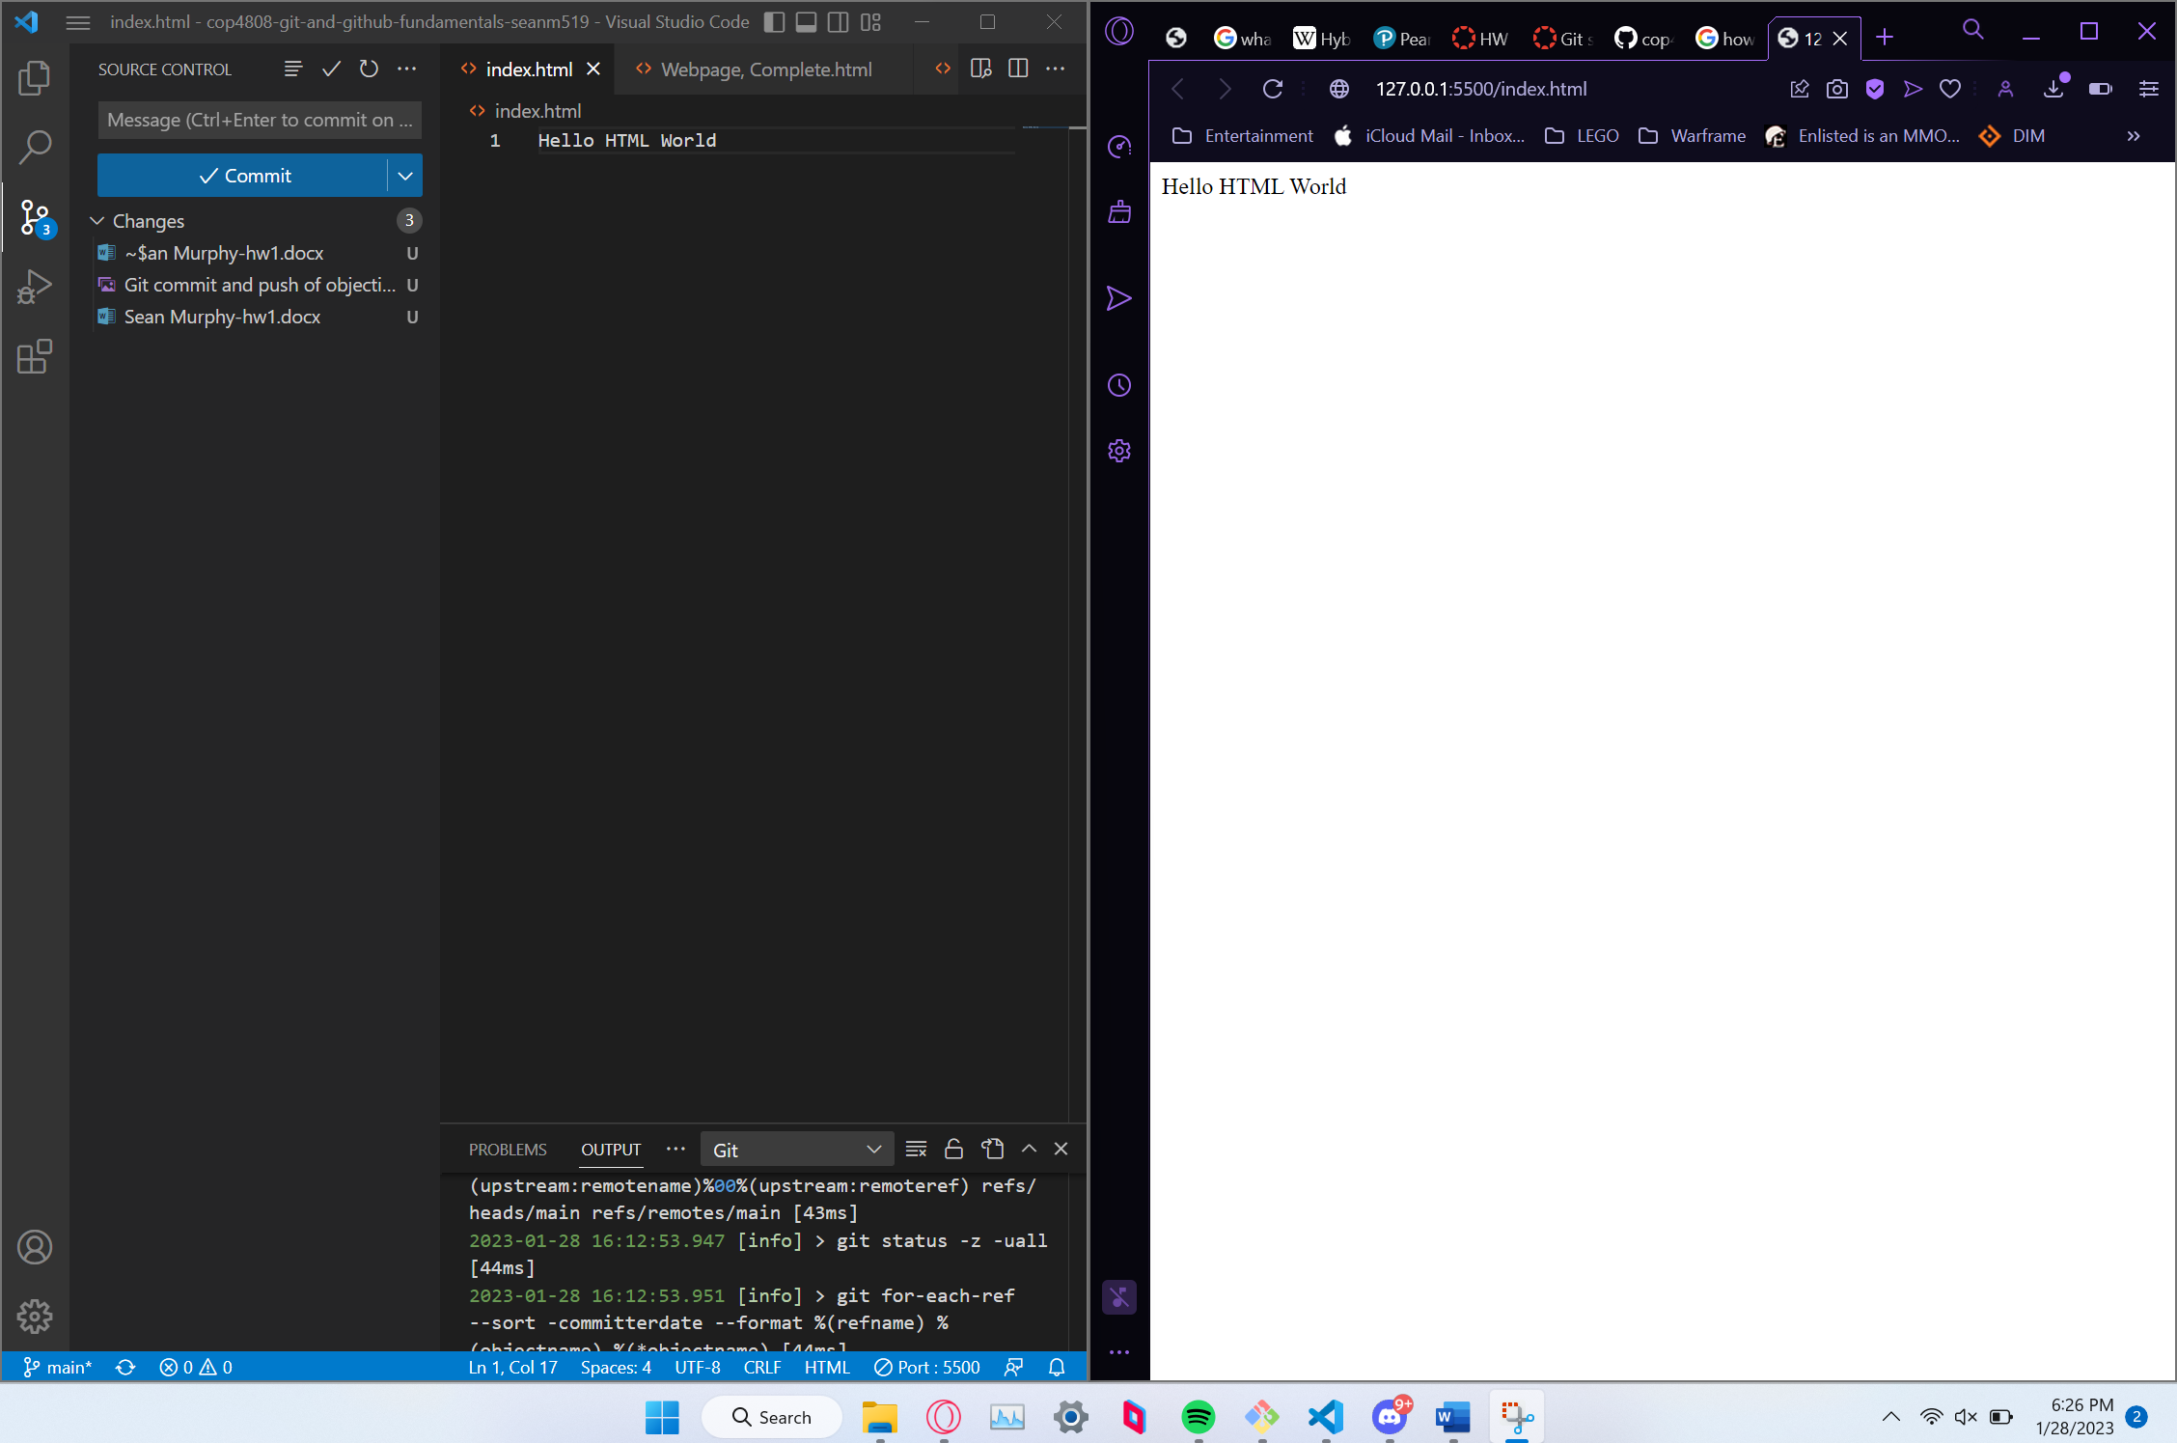

Objective 3:

I saved the webpage Calc You Later and moved the script and style files into their own files while adding my name and znumber to the top of the page. Additionally, I edited the code to tell it where to find the script and style files.Graphical user interface, application
